**Substrate 1a: Mud**

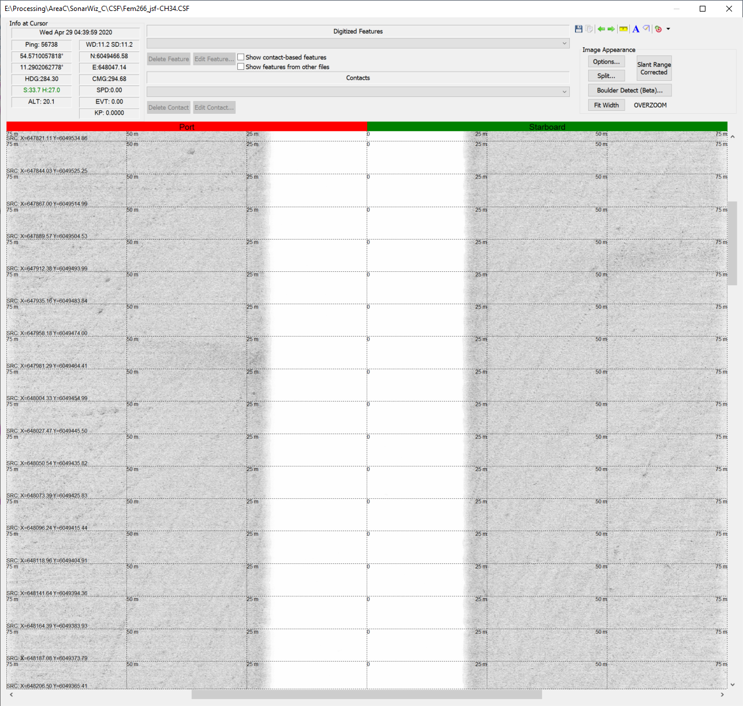

**Substrate 1a: Mud**

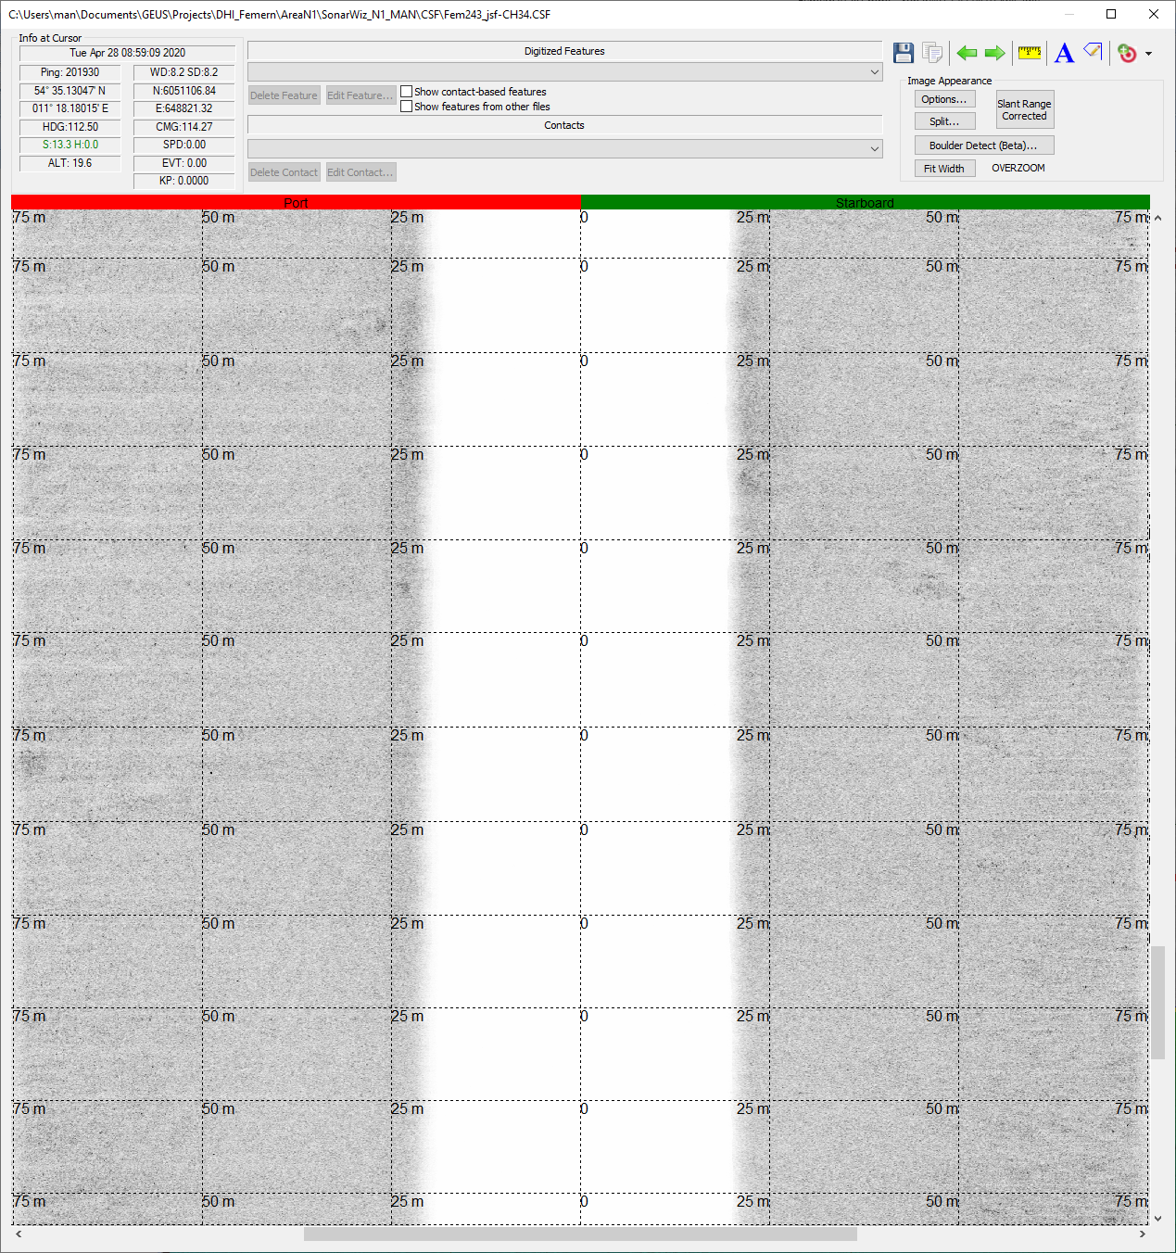

**Substrate 1b: Sand**

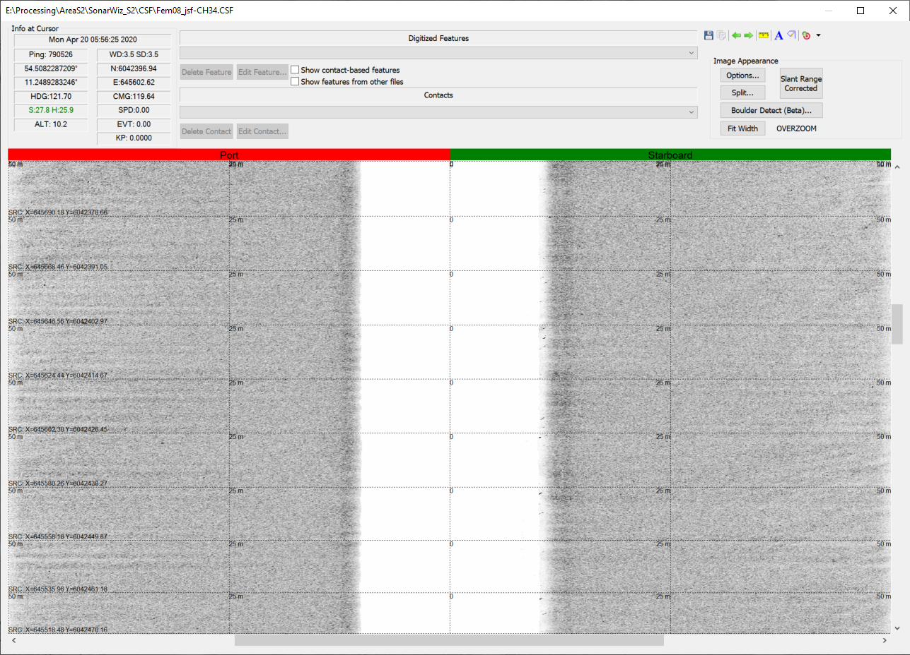

**Substrate 1b: Sand**

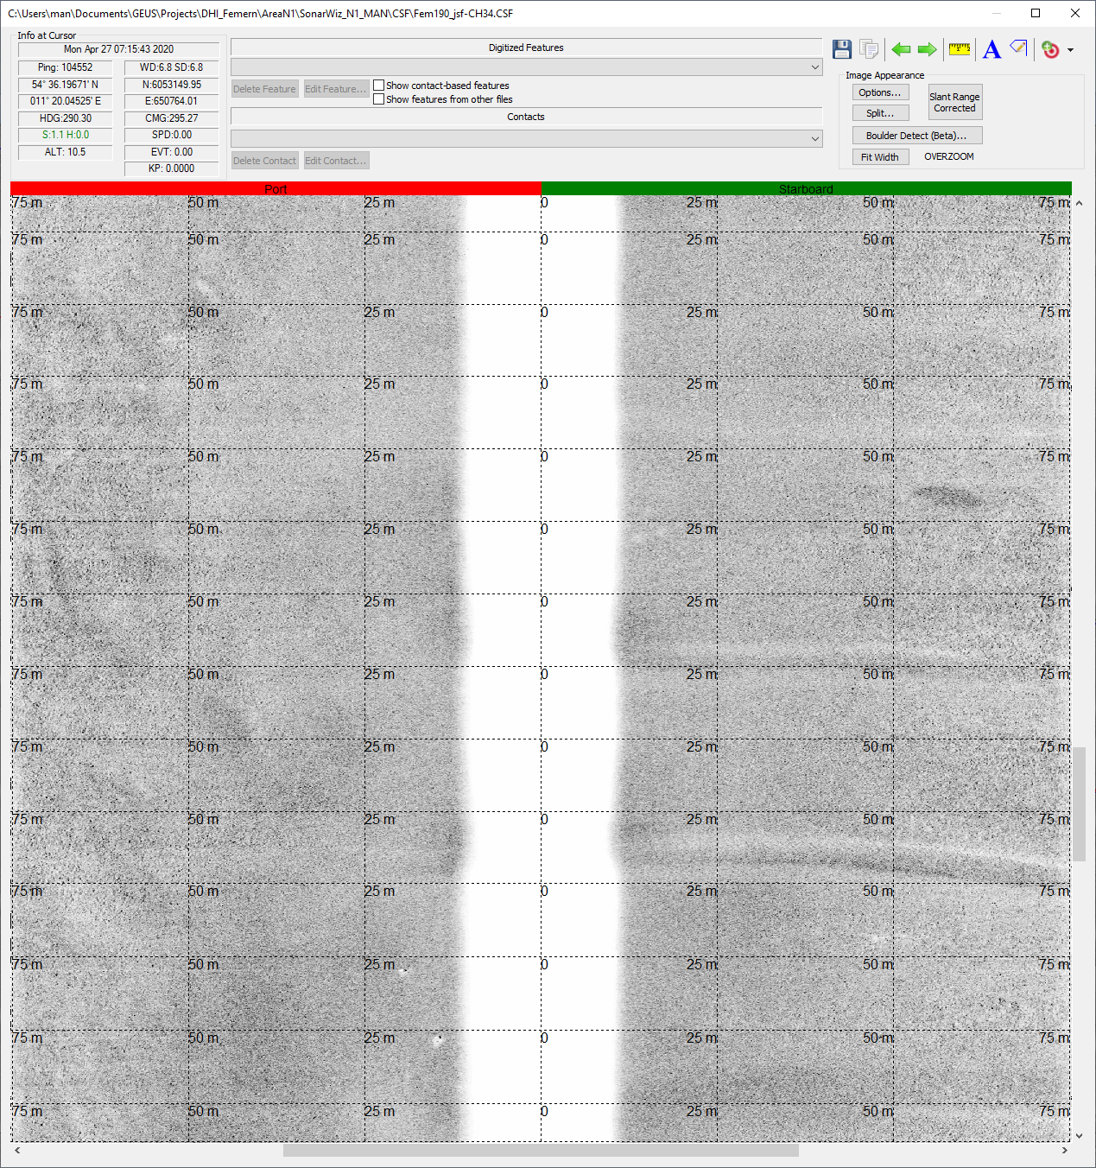

**Substrate 2: Gravelly sand (<10% stones)**

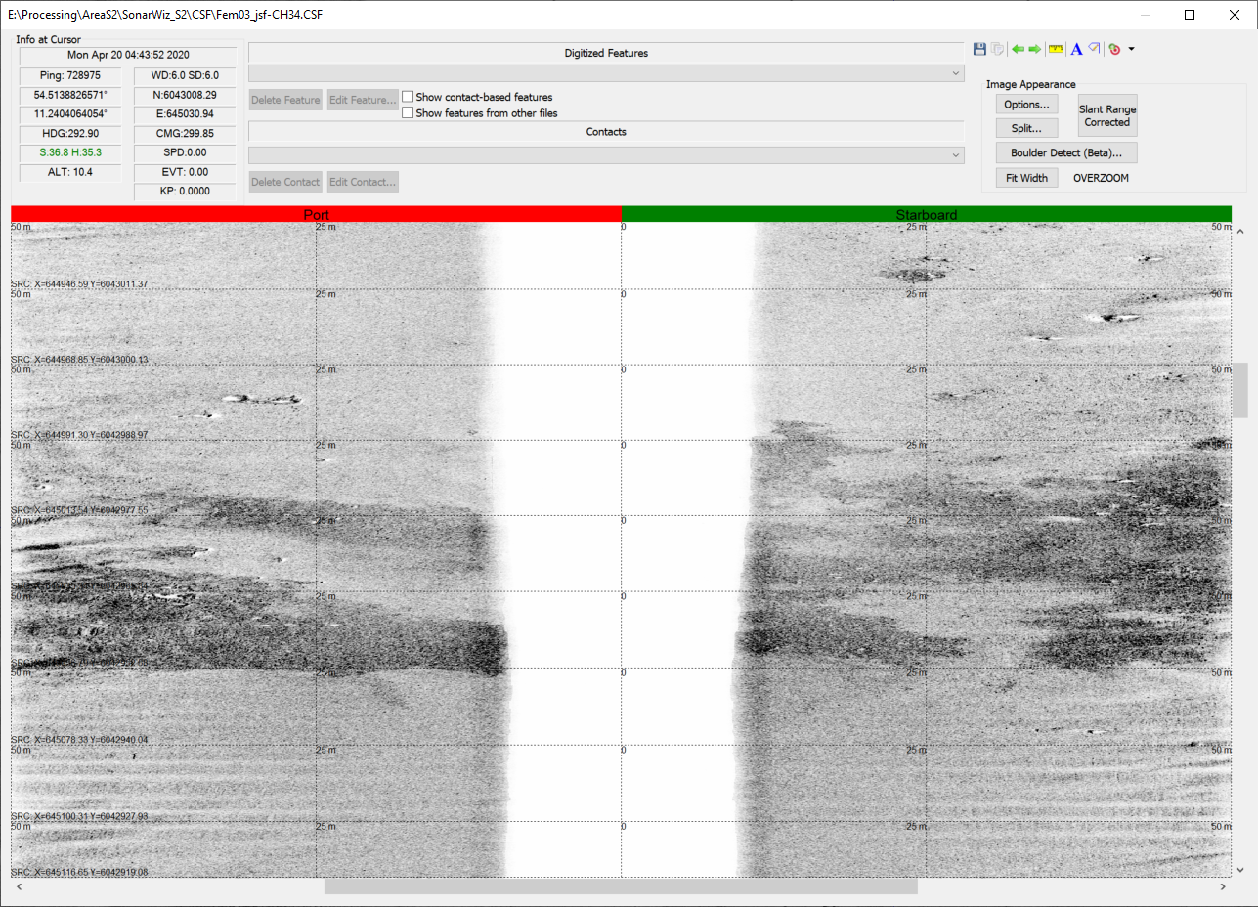

Example (white circle) of substrate class 2 (Gravelly sand (<10% gravel))

**Substrate 2: Gravelly sand (<10% stones)**

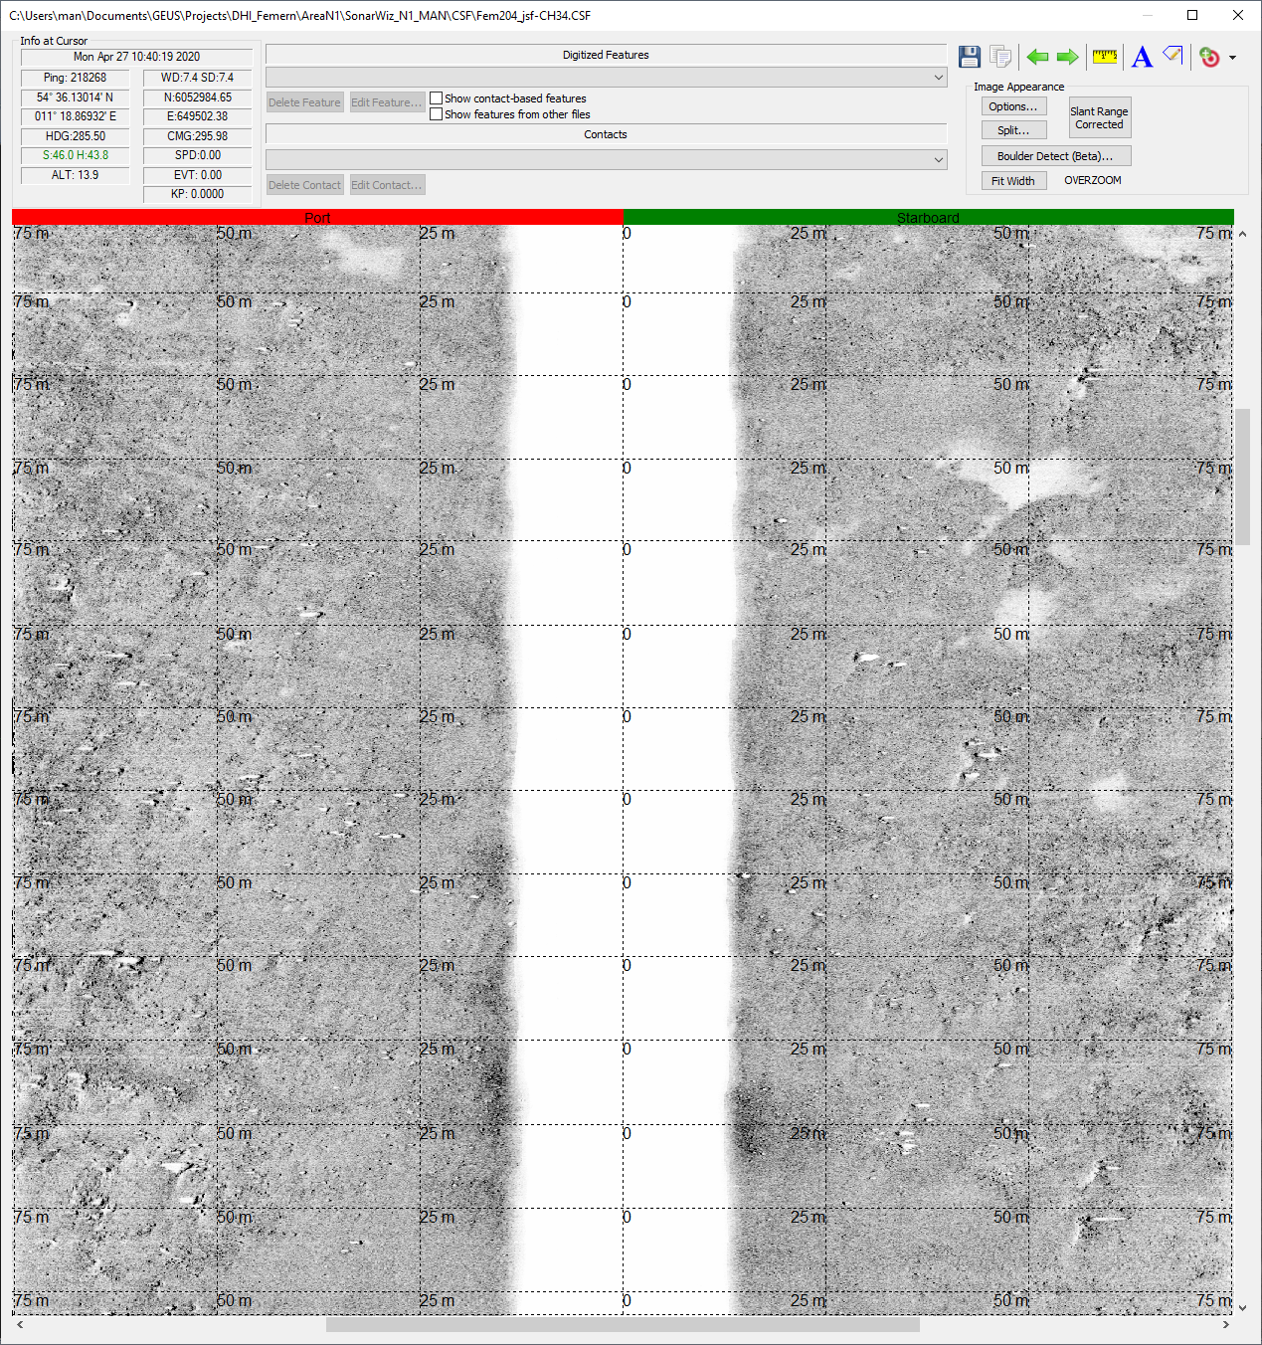**Substrate 3: Sandy gravel (10-25% stones)**

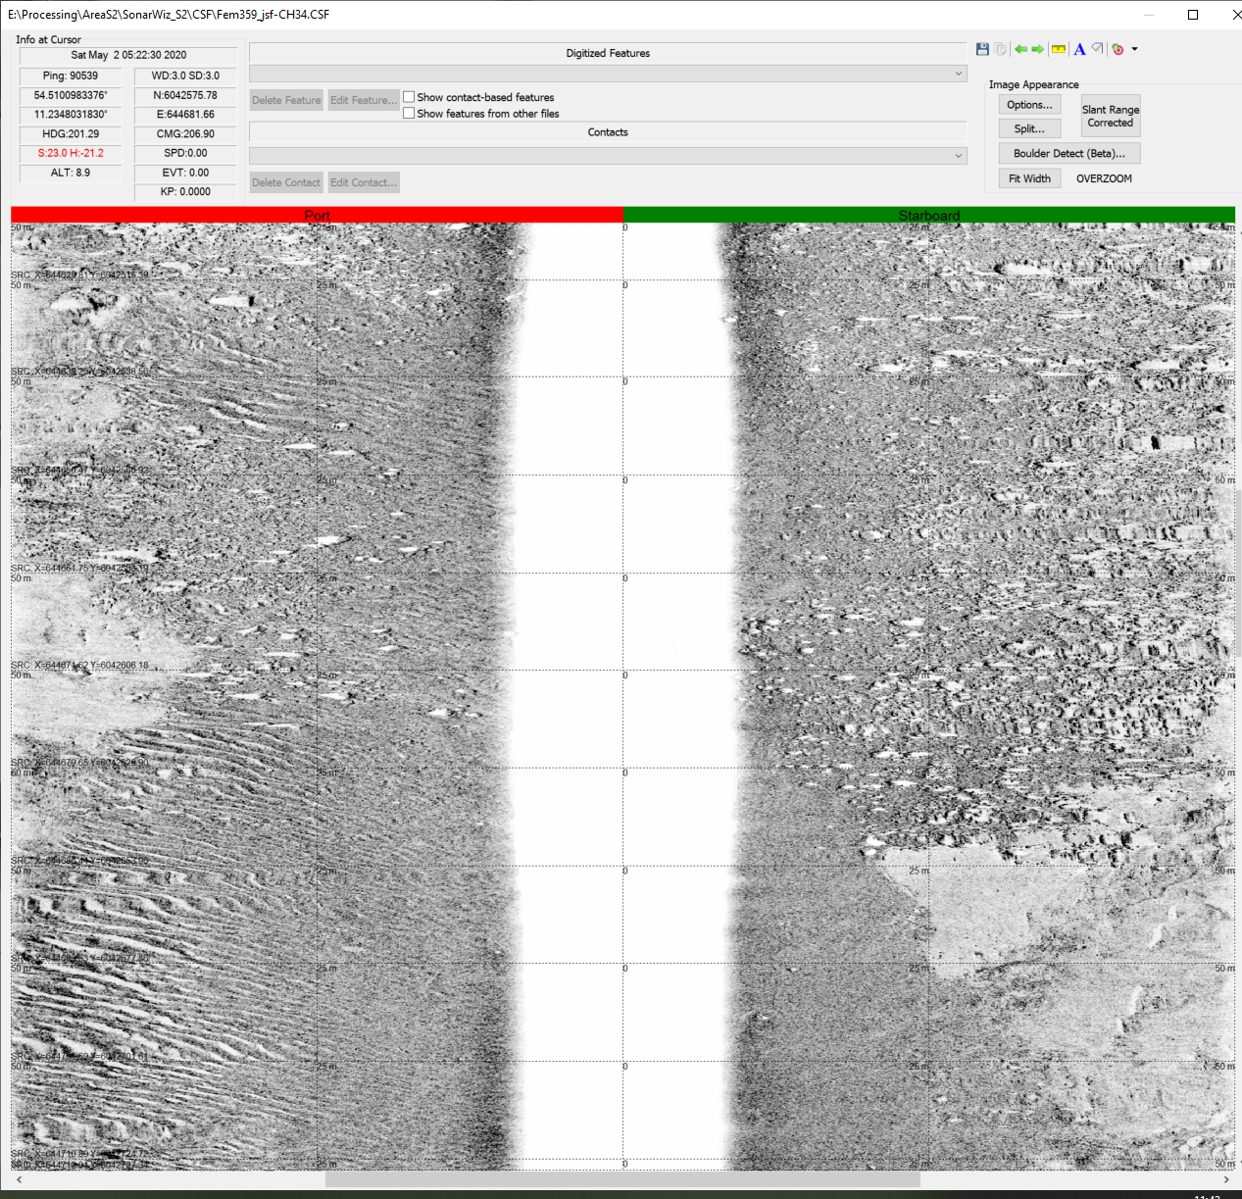**Substrate 3: Sandy gravel (10-25% stones)**

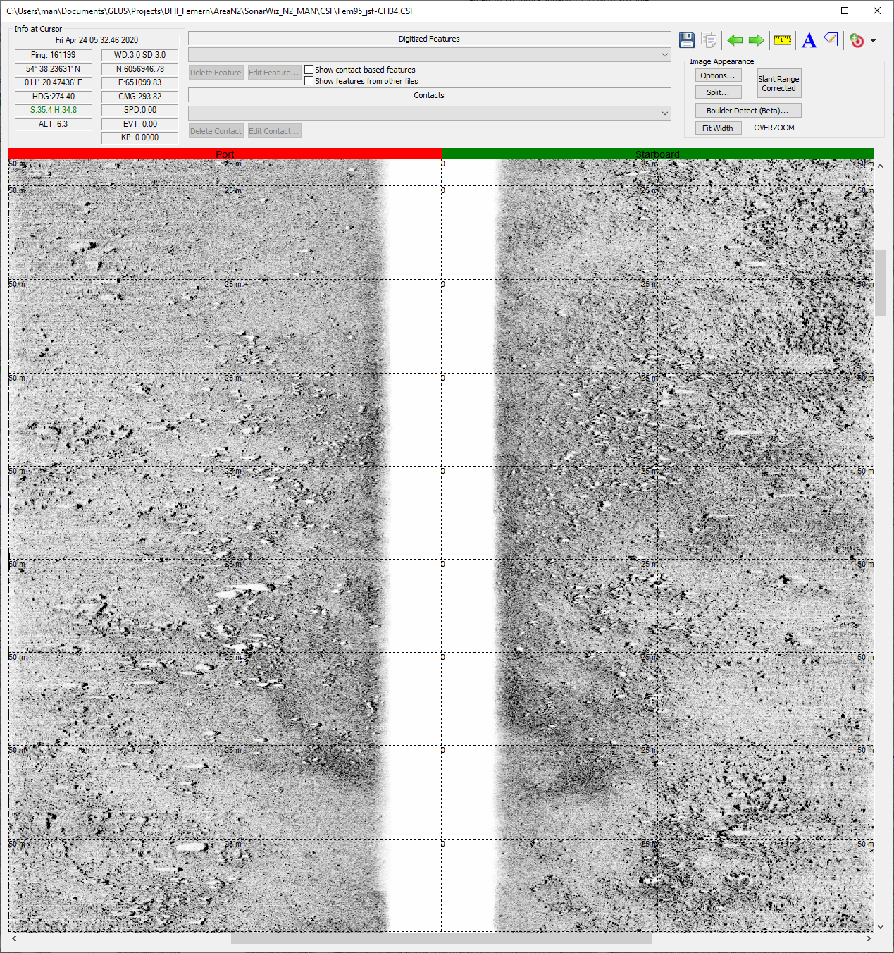

**Substrate 4: Gravel (>25% stones)**

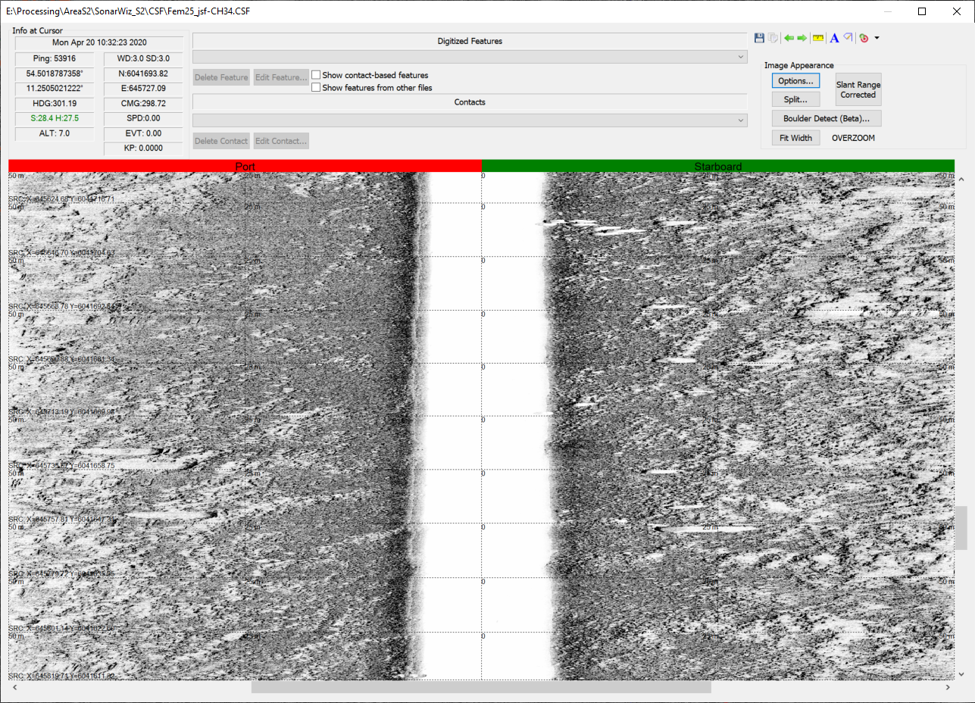

**Substrate 4: Gravel (>25% stones)**

